Software Design Document

GeoSwap: A Proximity-Based Mobile Barter Radar System



Submitted by
Arifa S23BINFT1M01204

Submitted to
Mr. Wahaj Ali

Department of Information Technology
Faculty of Computing
The Islamia University of Bahawalpur

Summary
The GeoSwap Software Design Document (SDD) serves as the technical blueprint for developing a proximity-based mobile barter radar system, translating the functional and non-functional requirements from the SRS into a scalable architectural framework. The system architecture adopts a multi-tier approach, utilizing a Flutter-based mobile frontend for responsive map interactions, a PHP-driven RESTful API for secure backend communication, and a Python-based middleware layer to execute high-performance geospatial logic and automated proximity-matching algorithms.
Key design considerations include the implementation of rigorous security protocols, such as AES-256 encryption for sensitive user data and coordinate "fuzzing" to ensure privacy, alongside database strategies designed to handle high concurrency and horizontal scaling. By detailing the data model schema, interface design philosophy, and controller-based system logic, this document establishes a structured technical foundation for the transition from the research and requirements phase to the application development phase, ensuring the platform remains intuitive, reliable, and optimized for real-time local resource sharing.

Table of Content
1. Application Architecture
- 1.1. Architectural Pattern
- 1.2. Proposed Components
- 1.3. Controller Functions
- 1.4. API and Library Integration
- 1.5. Coding Conventions
2. Data Model Schema
- 2.1. Entity Descriptions and Working Properties
- 2.2. Entity Relationships
- 2.3. Entity-Relationship (ER) Diagram
3. User Interface
- 3.1. Design Philosophy
- 3.2. Screen Descriptions and Controls
- 3.3. Screen-Level Logic
4. Security and Quality Assurance
- 4.1. Security Protocols
- 4.2. Testing Strategy
5. Conclusion

- Application Architecture
GeoSwap employs a three-tier layered architecture designed to decouple the user interface from business logic and data persistence, ensuring modularity and scalability.
1.1. Architectural Pattern
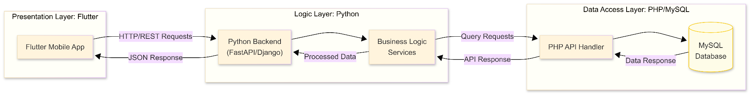
The application follows a modular structure where the Flutter frontend acts as the Presentation Layer, the Python middleware serves as the Logic Layer, and the PHP backend operates as the Data Access/API Layer.
Figure 1: GeoSwap Three-Tier System Architecture

1.2. Proposed Components
- Models: Represent the data structures for Users, Items, Transactions, and Audit Logs as defined in the database schema.
- Views: Flutter-based screens including the Radar Map, Item Detail View, Negotiation/Chat interface, and User Profile dashboard.
- Controllers: The bridge between the View and the data, managing user inputs and orchestrating business workflows.

1.3. Controller Functions
The following controllers manage the core operations of the application:
- RegistrationController: * validateCredentials(): Checks password length and format requirements.
  - processVerification(): Submits user identity documents for DEO/Admin approval.
- ItemManagementController:
  - uploadItem(): Processes item metadata, category, and images.
  - linkLocation(): Maps item coordinates to the GPS-linked database entry.
- RadarController:
  - fetchNearbyItems(): Queries the database based on the user's current coordinates and selected search radius.
  - applyFilters(): Updates map markers based on item categories or distance constraints.
- NegotiationController:
  - initiateSwap(): Creates a formal trade record between two users.
  - sendChatMessage(): Manages real-time data transmission within the chat hub.
- ModerationController:
  - flagContent(): Registers user reports in the Audit Log for Admin review.
  - approveAccount(): Updates user status from pending to verified.
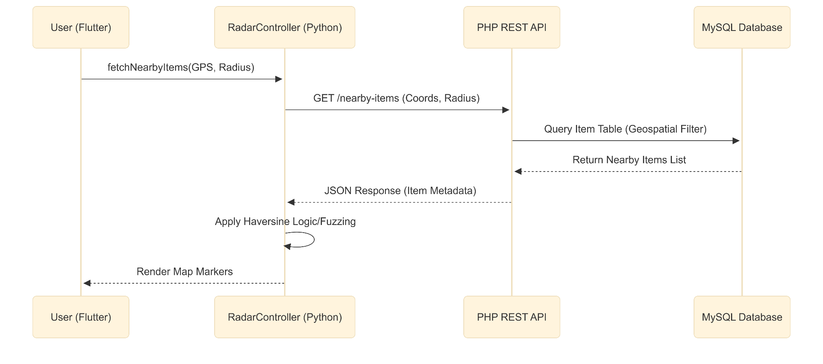
Figure 2: Sequence Diagram for Real-Time Radar Discovery (UC003)

1.4. API and Library Integration
- Internal API: A RESTful API developed in PHP handles all secure communication between the Flutter frontend and the MySQL database, managing requests for item listings, user authentication, and transaction updates.
- External APIs & Libraries:
  - Firebase Cloud Messaging (FCM): Used to dispatch push notifications to users when a relevant trade match is detected.
  - GPS/Geolocation Services: The application calls device-level location APIs to retrieve latitude/longitude data for the "Barter Radar".
  - Haversine Library: An external mathematical library used by the Python middleware to calculate accurate distances between coordinates for proximity matching.

1.5. Coding Conventions
- Naming: All components, variables, and functions follow camelCase naming conventions to ensure consistency across the cross-platform codebase.
- RESTful Standards: API endpoints are structured using standard HTTP verbs (GET, POST, PUT, DELETE) to facilitate clear interaction between the mobile client and the server.
- Modularity: Logic is partitioned; specifically, the Proximity Matching logic is encapsulated within the Python middleware to keep the mobile frontend lightweight.
- Data Model Schema
The GeoSwap system utilizes a relational database architecture in MySQL to maintain data integrity across the platform's core functional modules. This schema is designed to manage users, items, interactions, and moderation logs.
2.1. Entity Descriptions and Working Properties
Entity | Description | Key Properties
User | Registered participants and system roles. | user_id (PK), name, password_hash, address, phone, status (Pending/Verified), role (Admin/DEO/User).
Item | Tradable assets listed by users. | item_id (PK), user_id (FK), title, description, category, condition, lat, long, image_url_1, image_url_2, created_at.
Watchlist | Tracks user interests for notifications. | watchlist_id (PK), user_id (FK), keyword (e.g., "Electronics"), is_active.
Transaction | Manages barter agreement life-cycles. | trans_id (PK), item_a_id (FK), item_b_id (FK), sender_id (FK), receiver_id (FK), status (Pending/Accepted/Completed), timestamp.
Message | Real-time negotiation logs. | msg_id (PK), trans_id (FK), sender_id (FK), content, timestamp.
AuditLog | Moderation and security tracking. | log_id (PK), actor_id (FK), target_item_id (FK), action_taken, reason, timestamp.

2.2 Entity Relationships
- User to Item: One-to-Many. A user can create multiple listings; each item is owned by one user.
- User to Watchlist: One-to-Many. A user defines multiple keywords/categories to track via the Proximity Matching Notification (FR006).
- Item to Transaction: Many-to-One. Multiple transactions may reference an item (historically), but an item can only be part of one "Active" transaction at a time.
- Transaction to Message: One-to-Many. Each negotiation transaction contains multiple chat messages.
- User to AuditLog: One-to-Many. Admins/DEOs perform multiple moderation actions tracked within the log.

2.3 Entity-Relationship (ER) Diagram
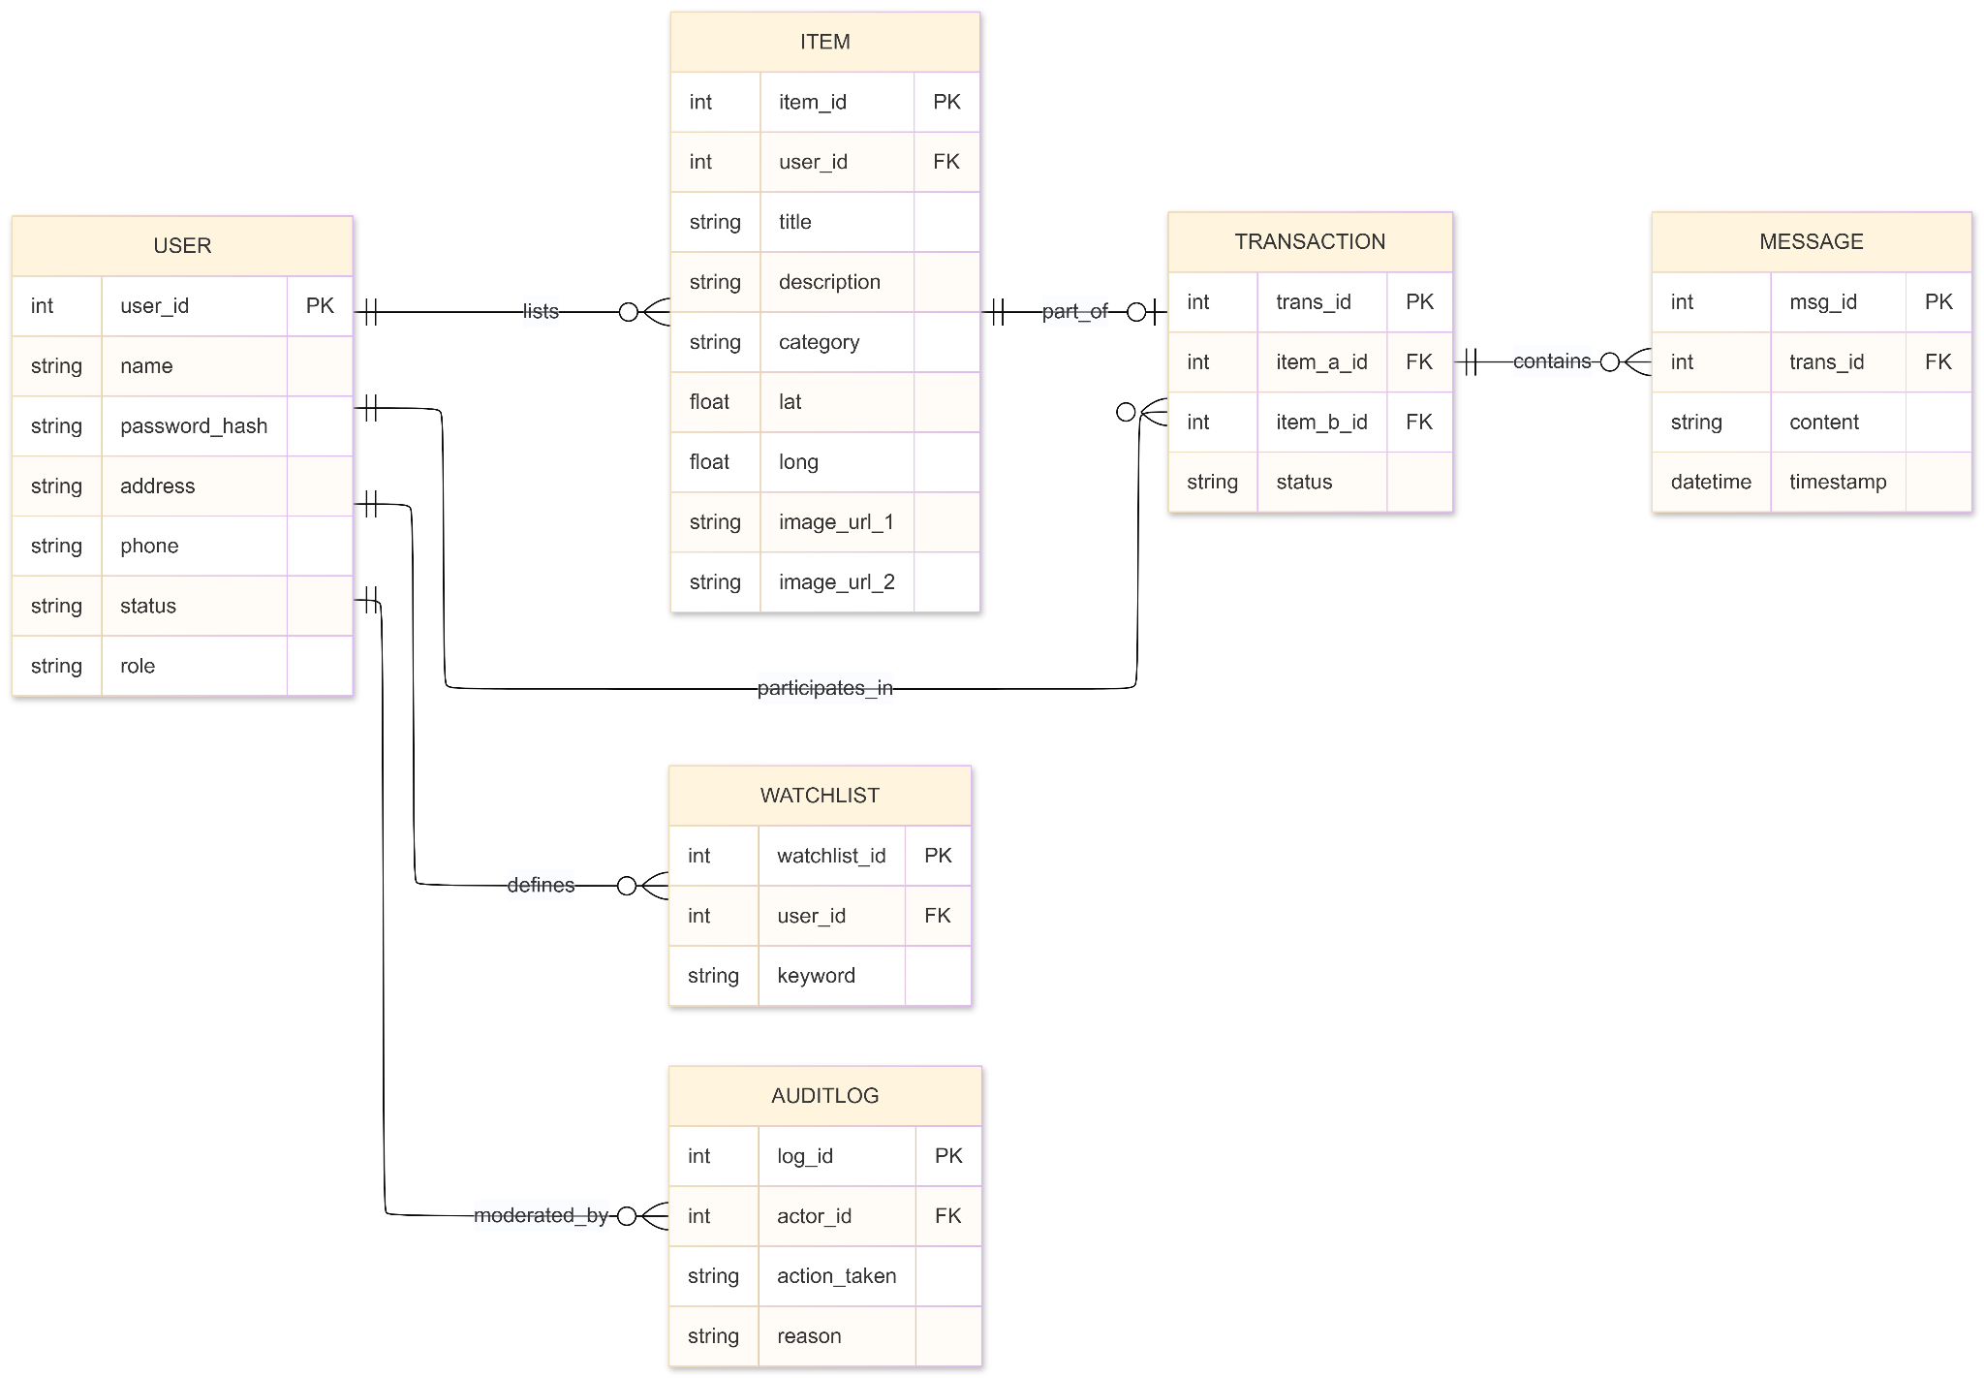
The following diagram provides a visual representation of the conceptual data schema defined above, mapping the entities and their respective relationships.

Figure 3: GeoSwap Conceptual ER Diagram. This diagram illustrates how the User, Item, Transaction, and Moderation modules are linked. The inclusion of geospatial coordinates in the Item entity enables the RadarController to query and display data accurately within the specified proximity radius.
- User Interface
The GeoSwap interface is designed for rapid navigation, requiring a maximum of two taps to switch between the core Radar, Listings, and Negotiation modules.

3.1 Design Philosophy
- Color Scheme: A high-contrast, professional palette using "Geo-Blue" for primary navigation and "Action-Green" for barter triggers to ensure visibility in outdoor lighting conditions.
- Font: A sans-serif, clean typeface (e.g., Roboto or Open Sans) to ensure readability on both budget smartphones and flagship devices (FR006/Compatibility).
- Design Niche: Minimalist. To prevent map clutter when multiple item markers appear, icons will be grouped into clusters at high zoom levels.
- Responsiveness & Constraints: The UI is adaptive, ensuring the Barter Radar remains functional across different screen sizes. All elements are constrained to be touch-friendly, adhering to Android (8.0+) and iOS (12.0+) guidelines.
3.2 Screen Descriptions and Controls
Screen Name | Page Content | UI Controls | Input Constraints
Registration | Identity and address entry forms. | Textbox (Name, Address), Phone Field, Image Picker (Display Pic). | Name: String; Password: 8+ chars (incl. numbers); Phone: Verified format.
Radar Map | Interactive map showing nearby tradeable items. | Map View, Radius Slider (Filter), Search Bar. | Radius: 1 km – 50 km; GPS input: Real-time.
Item Listing | Form to upload surplus goods. | Dropdown (Category), Textbox (Description), Image Picker (2 photos). | Category: Predefined list; Images: Min 2 high-quality uploads.
Negotiation | Real-time chat hub for swap logistics. | Message Textbox, "Accept Swap" Button, "Reject" Button. | Text input: Character limit applied for brevity.

3.3 Screen-Level Logic
- Registration Screen: The "Submit" button is disabled until all fields—including the mandatory "Latest clear face picture"—are validated by the frontend controller.
- Radar Screen: This screen utilizes the RadarController to calculate distances via the Haversine formula. The radius slider serves as the primary input constraint to manage the density of item icons on the map.
- Item Listing Screen: Uses the ItemManagementController. Location is automatically captured via the device’s GPS, but the user is provided with a "Manual Override" if they are listing an item from a different location (e.g., a secondary residence).
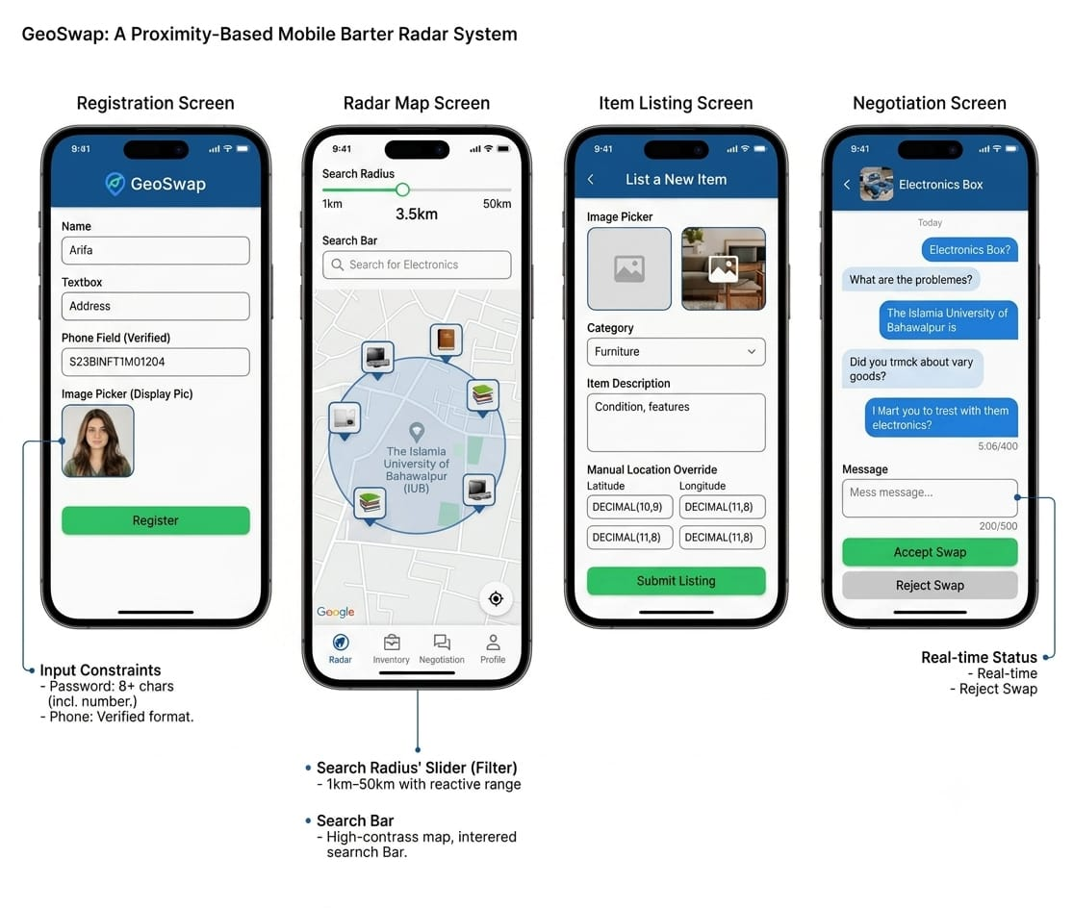
- Negotiation Screen: Displays the current status of the trade (Pending, Accepted, Finalized). Input is constrained to prevent spamming, and status updates are managed by the NegotiationController.

4. Security and Quality Assurance

4.1 Security Protocols
To ensure the integrity of the GeoSwap platform and protect user privacy, the following security measures are implemented:
- Data Encryption: Sensitive user credentials and personal information are secured using AES-256 encryption protocols.
- Privacy-Preserving Geolocation: To prevent exact location tracking, the system utilizes coordinate "fuzzing," which approximates user location data to protect user privacy while maintaining functional proximity matching.
- Input Sanitization: To prevent SQL injection and cross-site scripting (XSS), all inputs processed by the PHP REST API are sanitized before being executed against the MySQL database.
- Audit Logging: All administrative and moderation actions, such as account verification and content flagging, are recorded in the AuditLog entity for security tracking.

4.2 Testing Strategy
The system's reliability is validated through a multi-layer testing approach:
- Unit Testing: Individual controller functions (e.g., validateCredentials in RegistrationController) are tested to ensure they strictly adhere to business rules, such as password length and format requirements.
- Component Testing: The Python middleware is tested specifically for the accuracy of the Haversine distance calculations to ensure the proximity-matching algorithm functions correctly within the specified radius.
- Integration Testing: The interaction between the Flutter frontend, PHP API, and MySQL database is validated through end-to-end testing, specifically verifying that fetchNearbyItems requests return the correct JSON metadata.
- Boundary Testing: The Radar Map’s radius slider is tested against the defined constraints (1 km to 50 km) to ensure the UI behaves predictably at minimum and maximum threshold values.

5. Conclusion
The development of GeoSwap has successfully established a scalable and intuitive technical framework for a proximity-based mobile barter system. By integrating a three-tier architecture—leveraging the Flutter frontend for a responsive user experience, Python middleware for high-performance geospatial logic, and a PHP-driven RESTful API for secure backend communication—the platform effectively bridges the gap between digital listing and real-time local resource sharing.
Throughout this project, the implementation of rigorous security protocols, such as AES-256 encryption and coordinate "fuzzing," has ensured that user privacy remains a cornerstone of the application design. Furthermore, the methodical application of unit, component, and integration testing has confirmed the system's reliability in handling real-time data under diverse conditions. GeoSwap not only addresses the functional requirements of a modern barter radar but also provides a structured foundation for sustainable consumption, offering a reliable, user-centric solution for community-based asset exchange.

